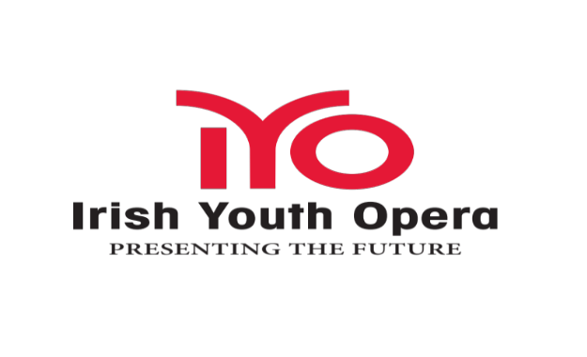
Irish Youth Opera is delighted to announce details of its 2015 Masterclass with mezzo-soprano Tara Erraught and pianist Henning Ruhe on March 28th 2015

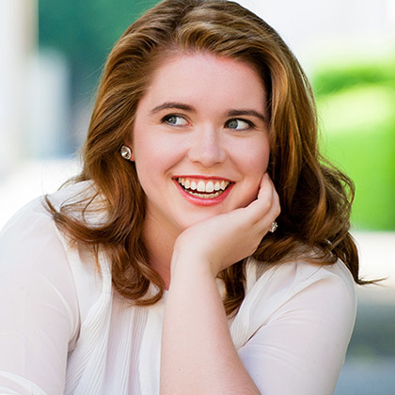

In keeping with IYO's committment to providing high-level professional training for young Irish opera singers through the medium of masterclasses, we are truely delighted to welcome Tara Erraught home to Ireland to share her skills in a masterclass for the first time. She will be joined by the pianist Henning Ruhe who is director of the Opera Studio at the Bavarian State Opera.

